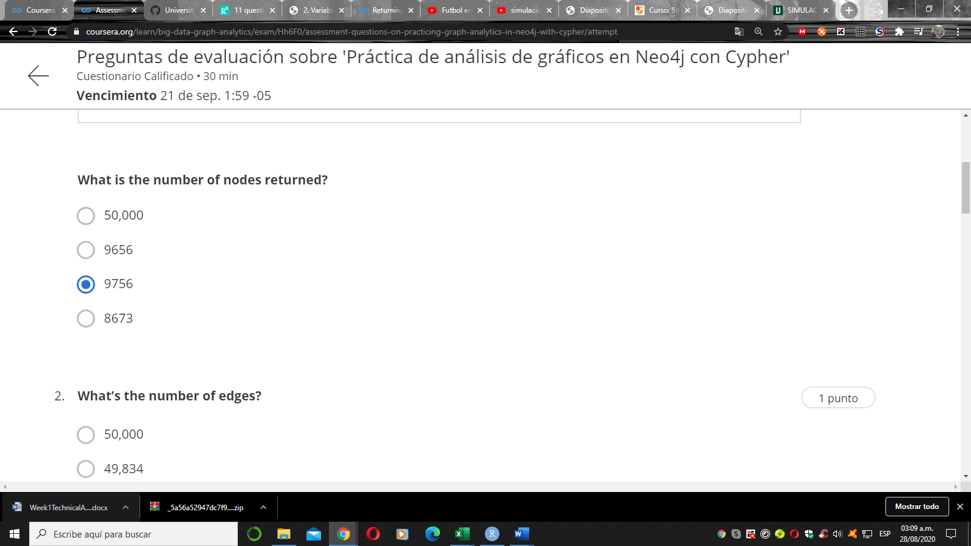

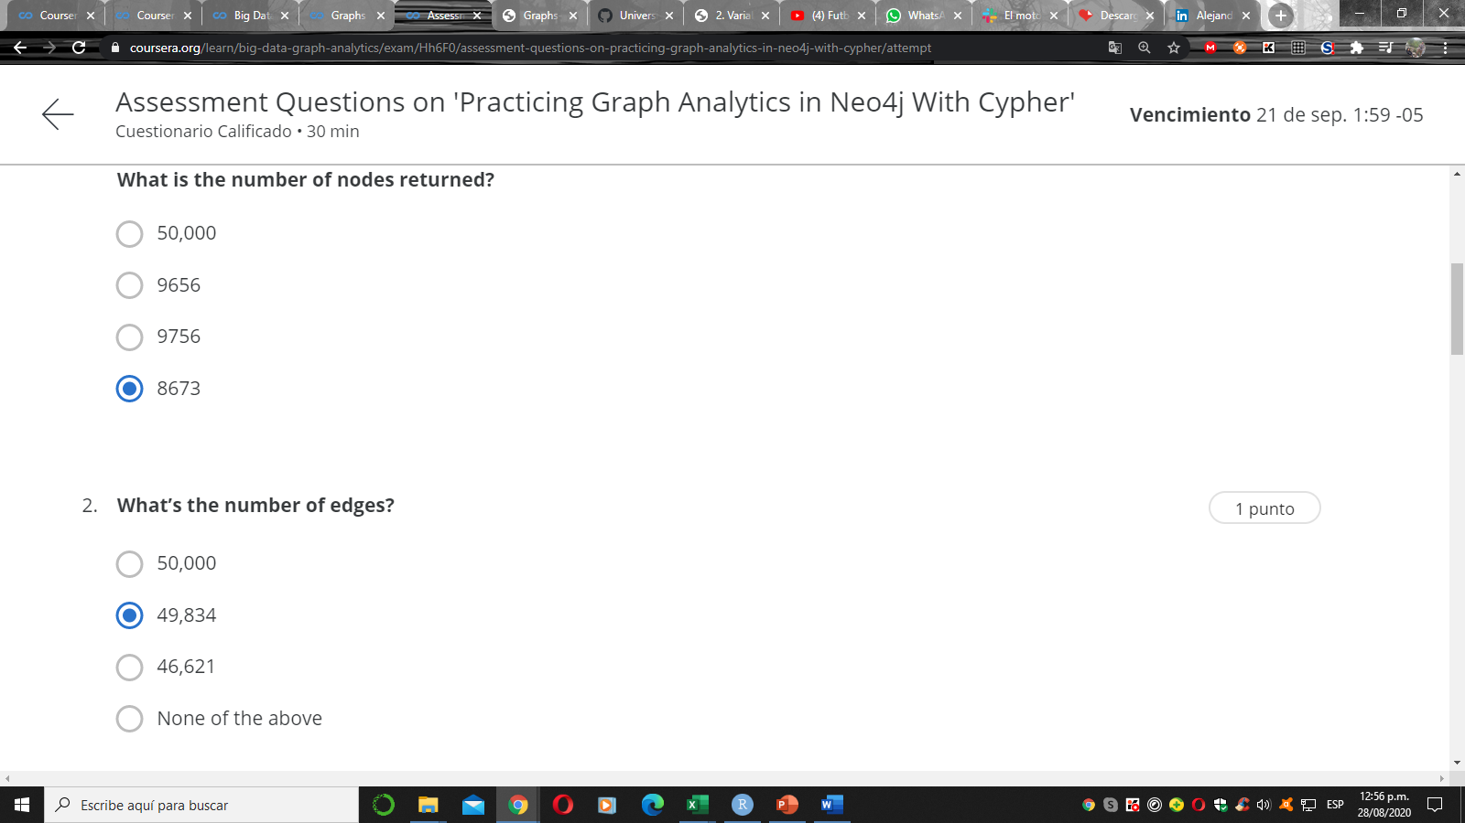
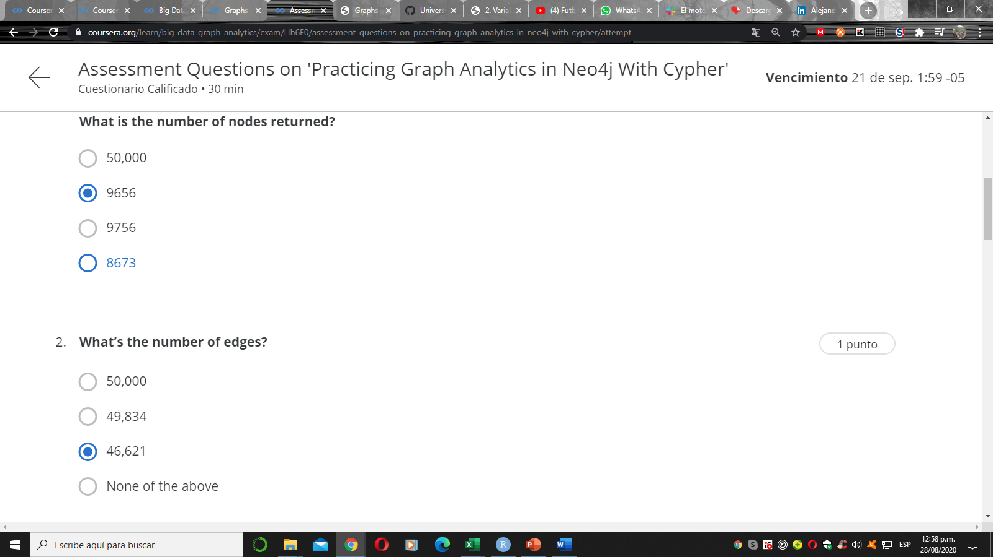
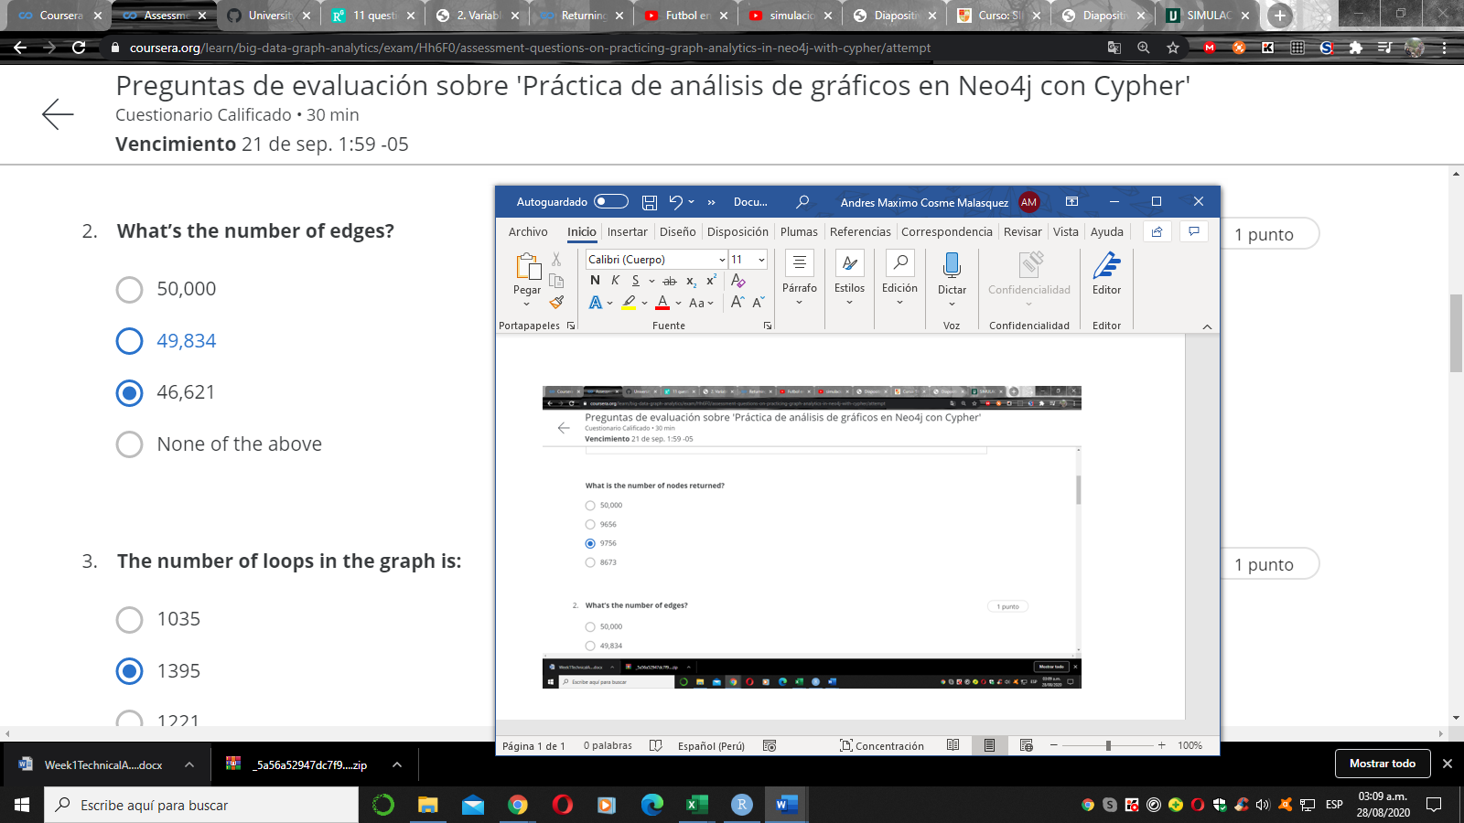
2 Correcta

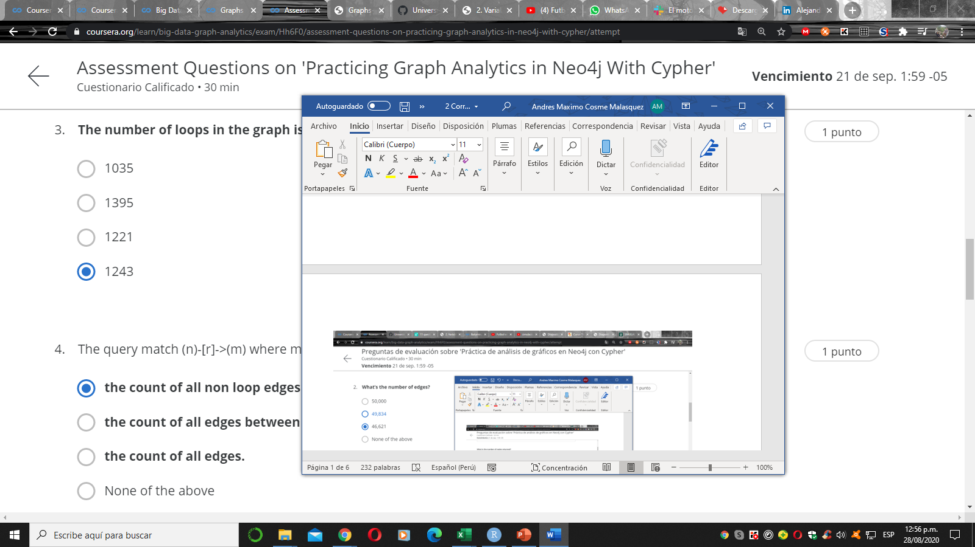
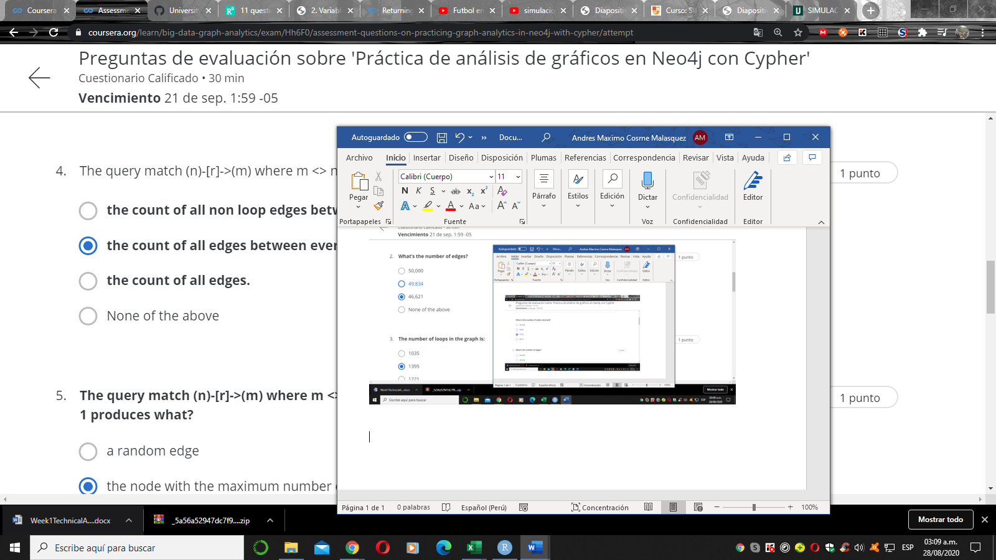
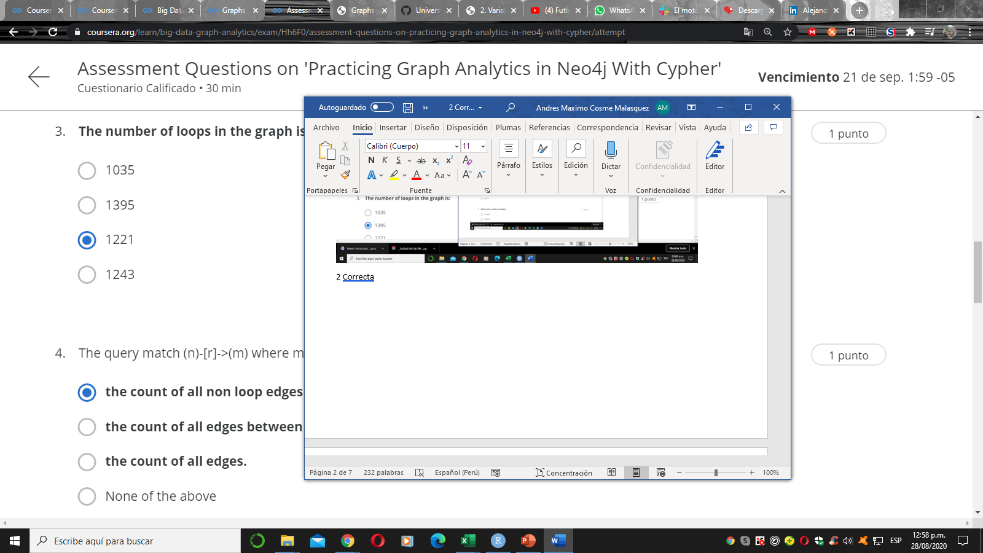
The count

5 .
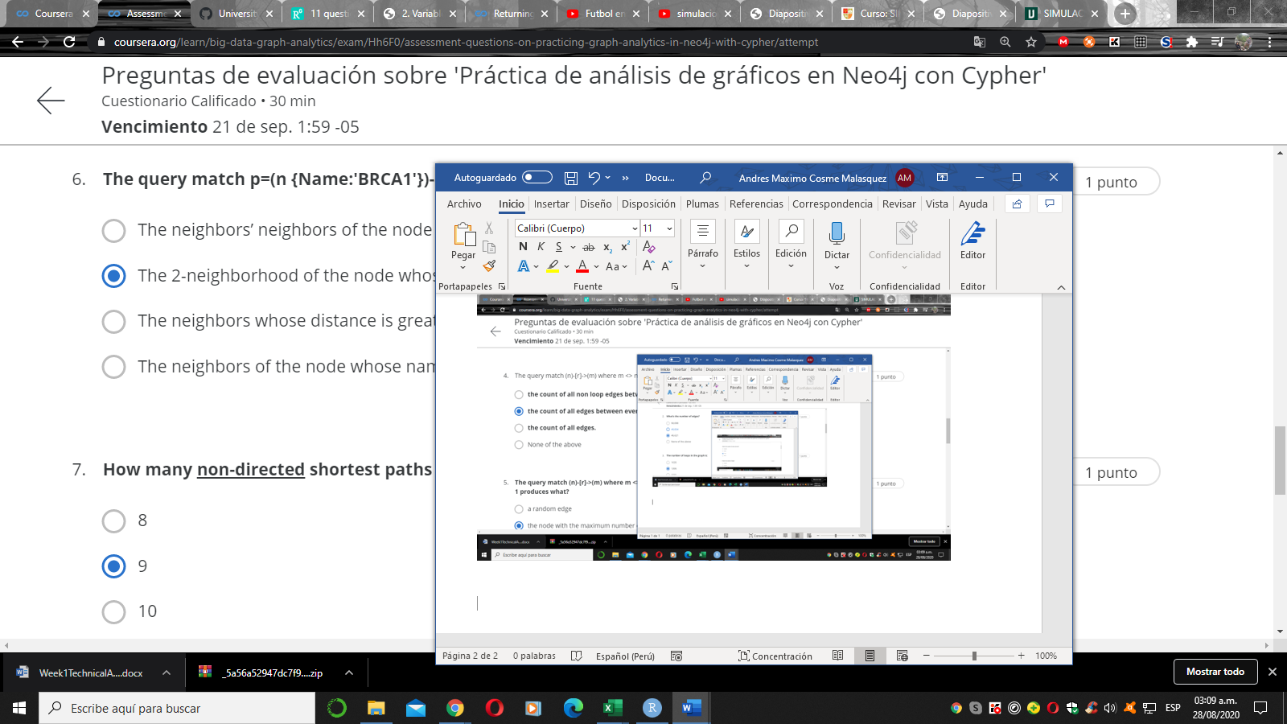
6. correcta
7Correcta
8Correcta
9Correcta

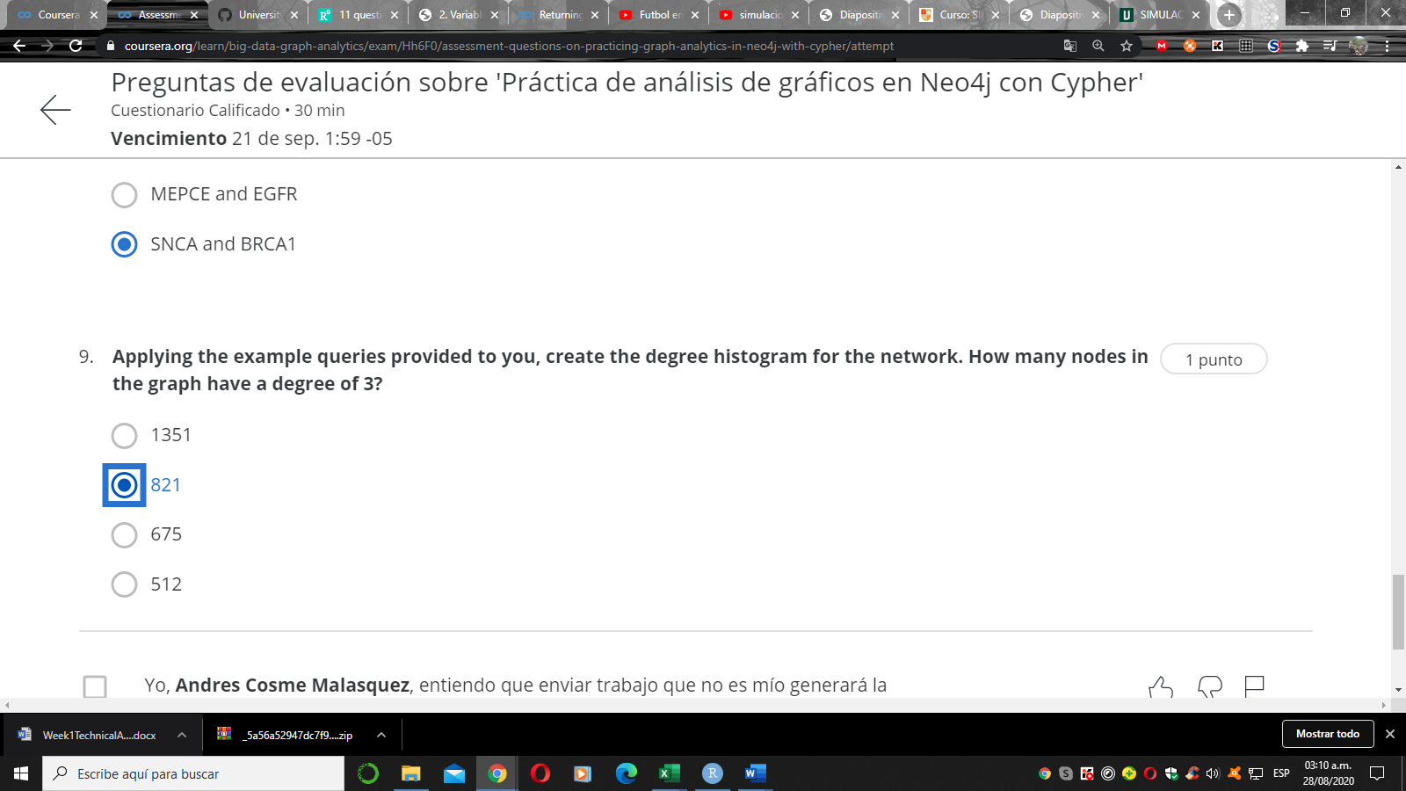

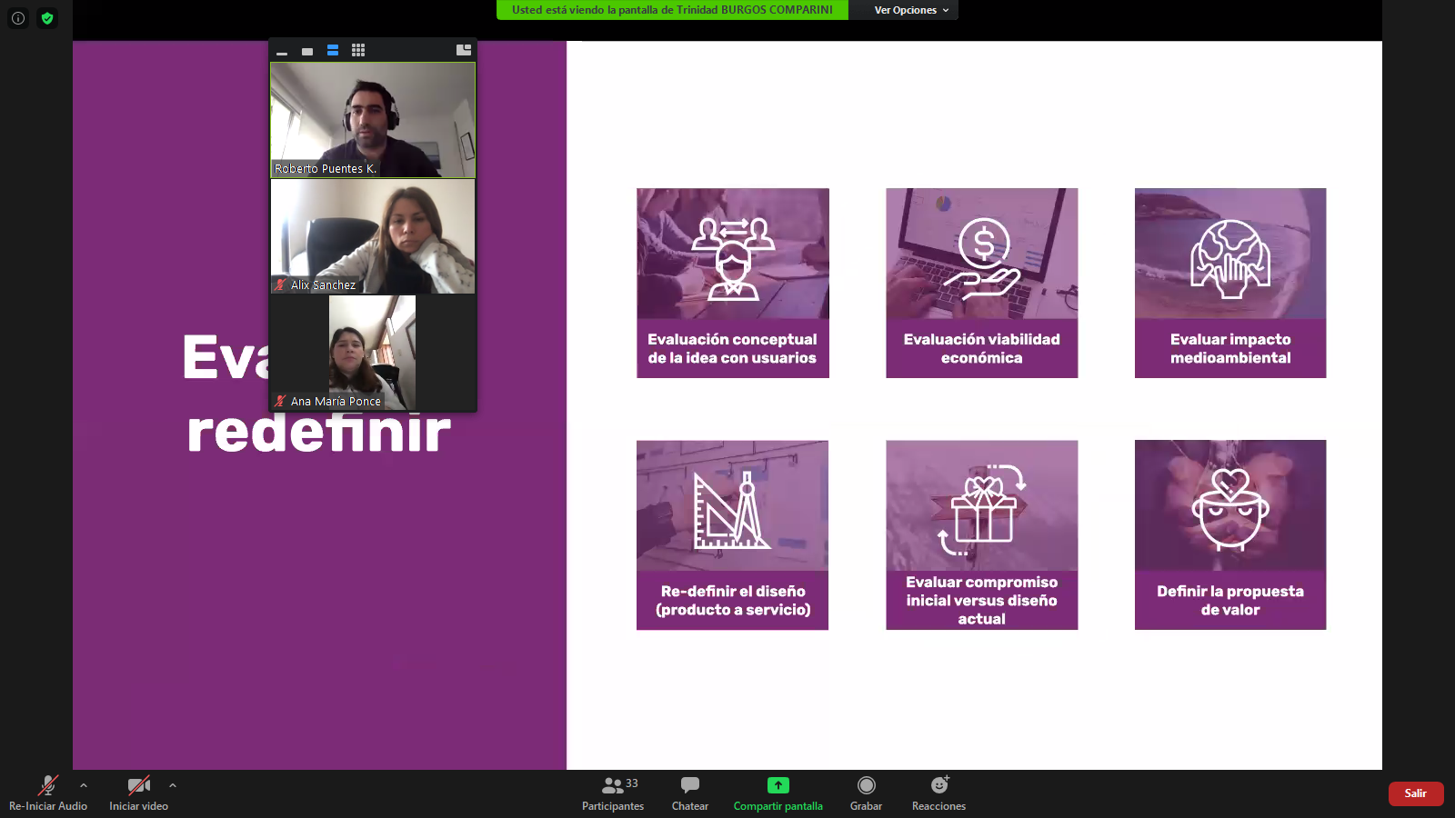

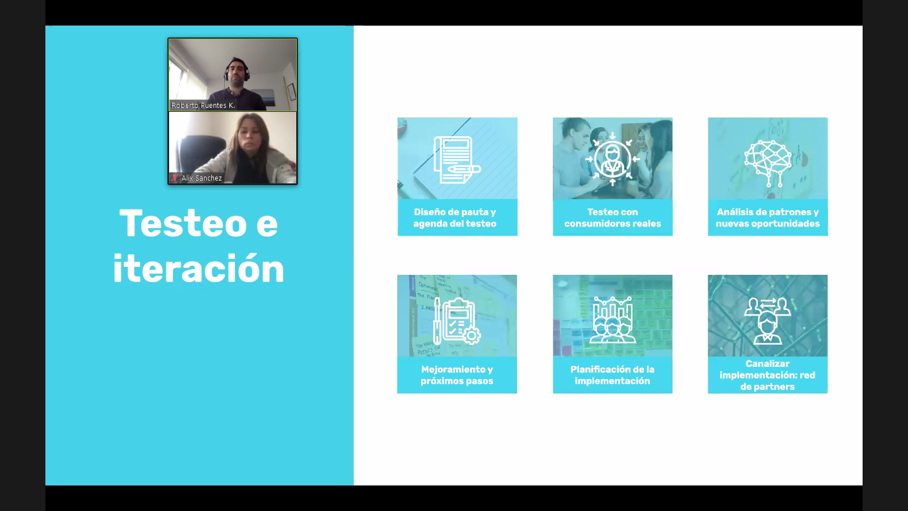

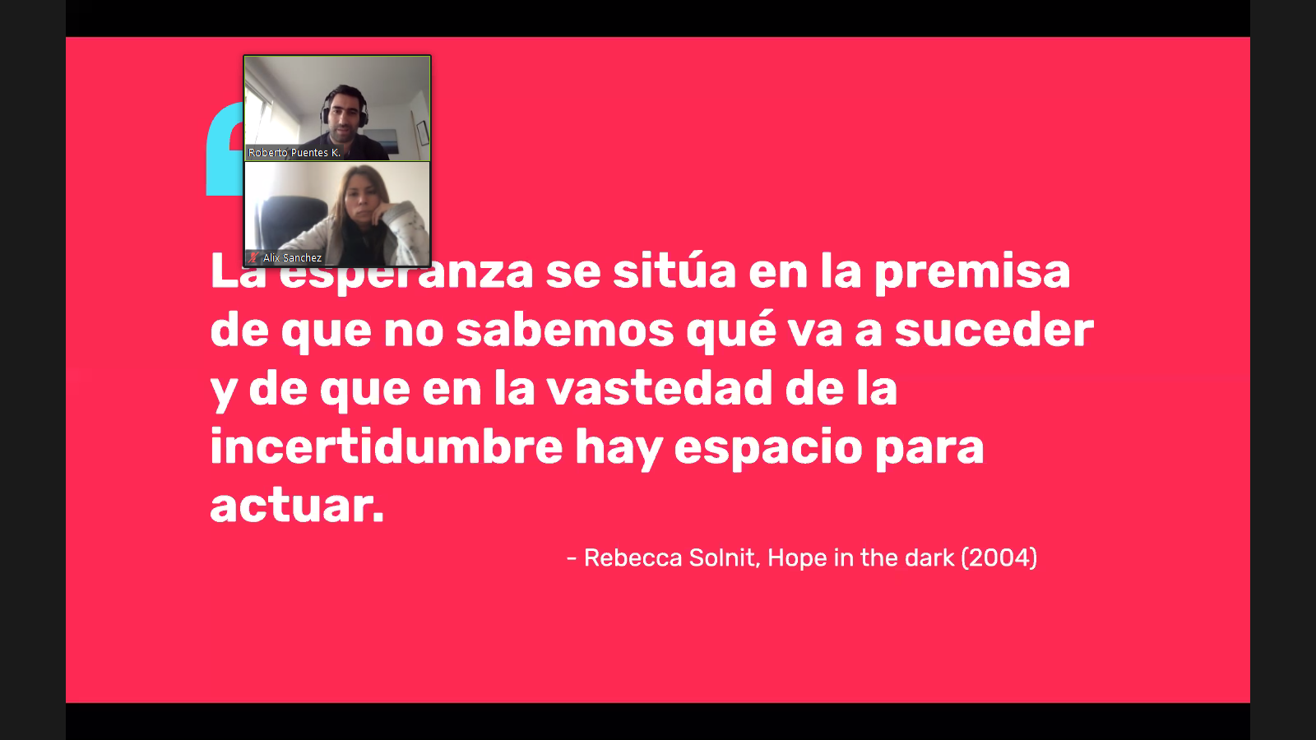

I think a simple Social Network in relation the scandalous default of FC. Barcelona against Bayer Munich. This have basic description, of create posts, comments based on these posts, chat, and reactions in pages. In the tables, lists of nodes and edge.
A social network how this can provide tons of questions and answers, for example:
Who are the pages with the most influence and flow of comments? Pages with many likes and reactions are the best candidates to define themselves as such. A useful metric is the degree of centrality.
What is the trend of reactions to each post? It is possible to define each publication that has influence on users and, according to this, notice trends.
What are the profiles of the most active users? Users on the page. With N likes and reactions, in the post, thanks to this it is possible to divide the most active users. For marketing and ad generation later.
if it is a page related to another topic. If you share a post regarding the topic. How much reception, reactions and comments can a publication like this raise? For example, a page related to entertainment, publishing a type of publication related to football, how it can influence different trends and if it is accepted, according to the profile of the users already defined.

